Dataset used=26
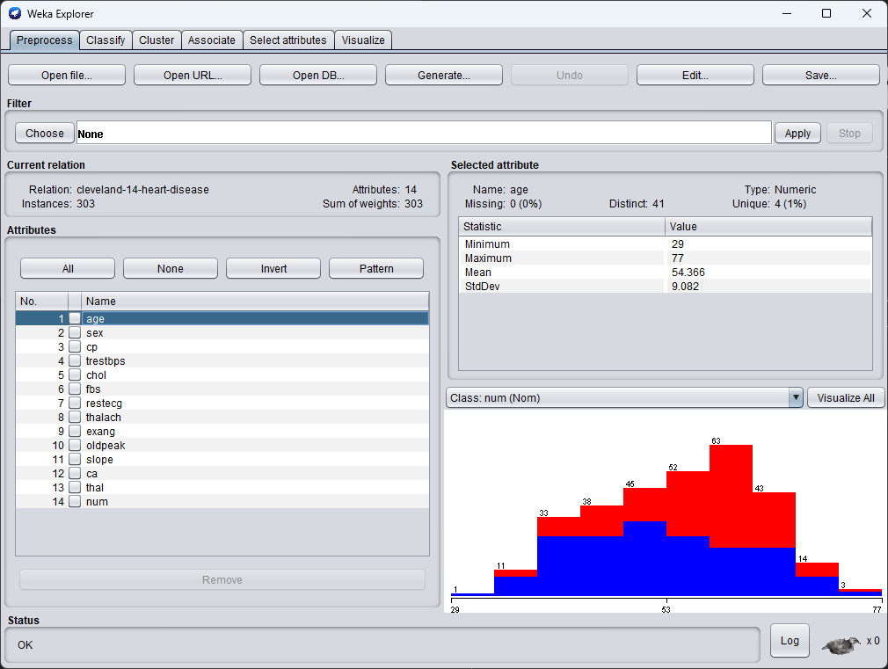
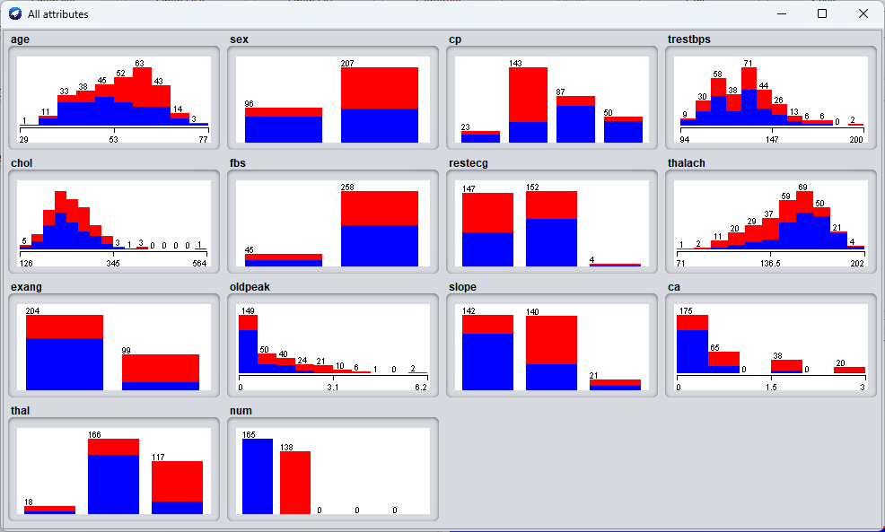
a)Explore dataset and understand the types of each attribute and aply preprocessing
- Oldpeak has the outlier and we will be normalizing it
- Ca also seems to have a outlier and we will normalize it
- Some missing values exist, we will apply missing values filter
b)Apply different data preprocessing techniques on different attributes.
b. normalization
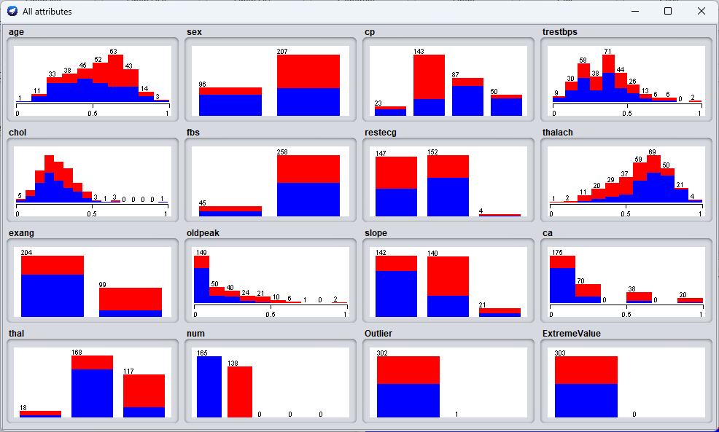
c) apply different tech
j-48
=== Stratified cross-validation ===
=== Summary ===

Correctly Classified Instances 232 76.5677 %
Incorrectly Classified Instances 71 23.4323 %
Kappa statistic 0.5251
Mean absolute error 0.1066
Root mean squared error 0.284
Relative absolute error 53.1558 %
Root relative squared error 90.1486 %
Total Number of Instances 303
naïve bayes
=== Stratified cross-validation ===
=== Summary ===

Correctly Classified Instances 252 83.1683 %
Incorrectly Classified Instances 51 16.8317 %
Kappa statistic 0.6593
Mean absolute error 0.0757
Root mean squared error 0.2332
Relative absolute error 37.7405 %
Root relative squared error 74.0231 %
Total Number of Instances 303
Smo
=== Stratified cross-validation ===
=== Summary ===

Correctly Classified Instances 255 84.1584 %
Incorrectly Classified Instances 48 15.8416 %
Kappa statistic 0.6776
Mean absolute error 0.1805
Root mean squared error 0.2873
Relative absolute error 89.9636 %
Root relative squared error 91.1884 %
Total Number of Instances 303

